Fuzzy Identity-Based Data Integrity Auditing for Reliable Cloud Storage Systems
ABSTRACT:
Data integrity, a core security issue in reliable cloud storage, has received much attention. Data auditing protocols enable a verifier to efficiently check the integrity of the outsourced data without downloading the data. A key research challenge associated with existing designs of data auditing protocols is the complexity in key management. In this paper, we seek to address the complex key management challenge in cloud data integrity checking by introducing fuzzy identity-based auditing, the first in such an approach, to the best of our knowledge. More specifically, we present the primitive of fuzzy identity-based data auditing, where a user’s identity can be viewed as a set of descriptive attributes. We formalize the system model and the security model for this new primitive. We then present a concrete construction of fuzzy identity-based auditing protocol by utilizing biometrics as the fuzzy identity. The new protocol offers the property of error-tolerance, namely, it binds with private key to one identity which can be used to verify the correctness of a response generated with another identity, if and only if both identities are sufficiently close. We prove the security of our protocol based on the computational Diffie-Hellman assumption and the discrete logarithm assumption in the selective-ID security model. Finally, we develop a prototype implementation of the protocol which demonstrates the practicality of the proposal.
EXISTING SYSTEM:
- Deswarte et al. proposed the concept of remote data integrity checking (RDIC, is also known as data integrity auditing), which comprises three parties, namely: cloud server, data owner and third party auditor (TPA). A publicly verifiable RDIC protocol allows the TPA or anyone to check the integrity of the stored data on the cloud without the need to retrieve the entire dataset.
- Ateniese et al. proposed a new notion of provable data possession (PDP) and gave two efficient c onstructions u sing h omomorphic verifiable tag (HVT) based on RSA algorithm. A HVT aggregates response of the challenged blocks into a single value, which significantly reduces the communication c osts between the server and the TPA.
- Shacham and Waters proposed the concept of proof of retrievability (POR), as well as providing a construction based on short signature algorithm and proving its security in the random oracle model.
DISADVANTAGES OF EXISTING SYSTEM:
- Firstly, generation, management and revocation of certificates is complex and computationally expensive, and consequently scalability is challenging.
- Secondly, the level of trust required of CA may be unrealistic, particularly in light of recent high profile incidents.
PROPOSED SYSTEM:
- In this paper, we seek to simplify key management issue of remote data integrity auditing protocols by introducing biometric-based identities in traditional RDIC protocols. We regard our contributions to be three-fold.
- We propose the notion of fuzzy identity-based data integrity auditing designed to simplify key management.
- We then formalize the system model and security model to ensure the security called soundness of this new primitive (i.e. if a cloud server can convince a verifier that the server is storing a file, if and only if it is actually storing that file).
- We describe a concrete construction of fuzzy identity-based data integrity auditing protocol, by borrowing the idea of fuzzy identity-based encryption due to Shacham and Waters.
ADVANTAGES OF PROPOSED SYSTEM:
- We prove that the biometric-based data integrity auditing protocol achieves the property of soundness.
- Even if a cloud server exhibits arbitrary dishonest behavior, the server must store the file with a high probability provided that it generates a valid response for a challenge of the file.
SYSTEM ARCHITECTURE:
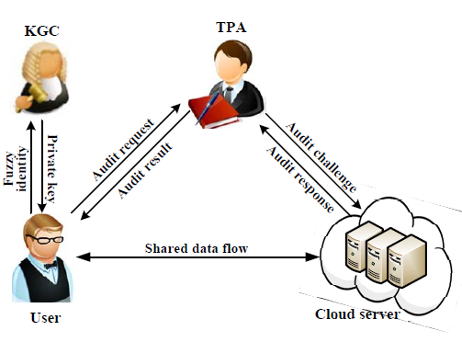
SYSTEM REQUIREMENTS:
HARDWARE REQUIREMENTS:

- System : Pentium Dual Core.
- Hard Disk : 120 GB.
- Monitor : 15’’ LED
- Input Devices : Keyboard, Mouse
- Ram : 1 GB

SOFTWARE REQUIREMENTS:

- Operating system : Windows 7.
- Coding Language : JAVA.
- Tool : Netbeans 7.2.1
- Database : MYSQL

REFERENCE:
Yannan Li, Yong Yu_, Geyong Min, Willy Susilo, Jianbing Ni and Kim-Kwang Raymond Choo, “Fuzzy Identity-Based Data Integrity Auditing for Reliable Cloud Storage Systems”, IEEE Transactions on Dependable and Secure Computing, Volume: 16 , Issue: 1 , Jan.-Feb. 1 2019.

